Who can a formal complaint be made to?

Directly to the Practice or Leicester, Leicestershire, and Rutland Integrated Care Board (LLR ICB) directly. A claimant cannot do both and must choose which service to complain to.

By telephone: 0116 295 7572
Email: llricb-llr.enquiries@nhs.net
Or write to them at:
Corporate Affairs Team
Leicester, Leicestershire ICB
Room G30, Pen Lloyd Building, County Hall
Glenfield
Leicester
LE3 8TB

If you remain dissatisfied with the responses to your complaint, you have the right to ask the Health Ombudsman to review your case. The contact details are:
The Parliamentary and Health Service Ombudsman
Millbank Tower
Millbank
London
SW1P 4QP

Complaints helpline: 0345 015 4033
(Mon-Fri 8:30am - 5:30pm)
Website: www.ombudsman.org.uk
If you need any help or advice to make your complaint to the Ombudsman, you can contact your local NHS Complaints Advocacy Service who provide independent advocacy for people who have a complaint about the NHS. The details of your local office can be found at:
www.pohwer.net and their phone number is: 0300 456 2370.

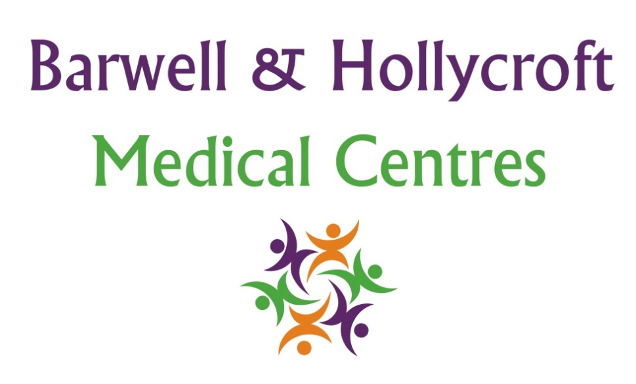

Complaints Procedure

Making a complaint

Most problems can be sorted out quickly and easily, often at the time they arise with the person concerned and this should be the approach you try first.
If your problem cannot be sorted out in this way and you wish to make a complaint, we would like you to let us know as soon as possible. Complaints can be made in writing, electronically or verbally - ideally within a matter of days or at most a few weeks - because this will enable us to establish what happened more easily. If it is not possible to do that, please let us have details of your complaint:

Within 12 months of the incident that caused the problem

Or
within 12 months of you discovering the incident giving as much detail as you can.
If you are a registered patient, you can complain about your own care. You are unable to complain about someone else’s treatment without their written authority. See the separate section in this leaflet.

For written complaints, please send to:
The Practice Manager, Barwell & Hollycroft Medical Centres, Jersey Way, Barwell, Leicestershire LE9 8HR
The practice Complaints Manager is: Sarah Gibson

What we do next

We look to settle complaints as soon as possible.
We will acknowledge receipt within 3 working days and aim to have investigated the matter within 30 days. If we need to extend this timeframe, we will inform the claimant in writing. You may then receive a formal reply in writing, or you may be invited to meet with the person(s) concerned to attempt to resolve the issue.
When looking into a complaint we attempt to see what happened and why, to see if there is something we can learn from this and make it possible for you to discuss the issue with those involved if you would like to do so.
When the investigations are complete your complaint will be determined, and a final response sent to you.
Where your complaint involves more than one organisation (e.g., social services) we will liaise with that organisation so that you receive one coordinated reply, we may need your consent to do this. Where your complaint has been sent initially to an incorrect organisation, we may seek your consent to forward this to the correct person to deal with.
The final response letter will include details of the result of your complaint and your right to escalate the matter further if you remain dissatisfied with the response.

Complaining on behalf of someone else

We keep to the strict rules of medical and personal
confidentiality. If you wish to make a complaint and are not the patient involved, we will require the written consent of the patient to confirm that they are unhappy with their treatment and that we can deal with someone else about it.

Where the patient is incapable of providing consent due to illness or accident it may still be possible to deal with the complaint. Please provide the precise details of the circumstances which prevent this in your covering letter. If you have any type of Power of Attorney, please enclose evidence of such so we can respond accordingly.

Please note that we are unable to discuss any issue relating to someone else without their express
permission, which must be in writing, unless the circumstances above apply.
We may still need to correspond directly with the patient or may be able to deal directly with the third party, and this depends on the wording of the authority provided.

